QUERY DATA BASE APOTEK

1. SELECT*FROM data jenis obat

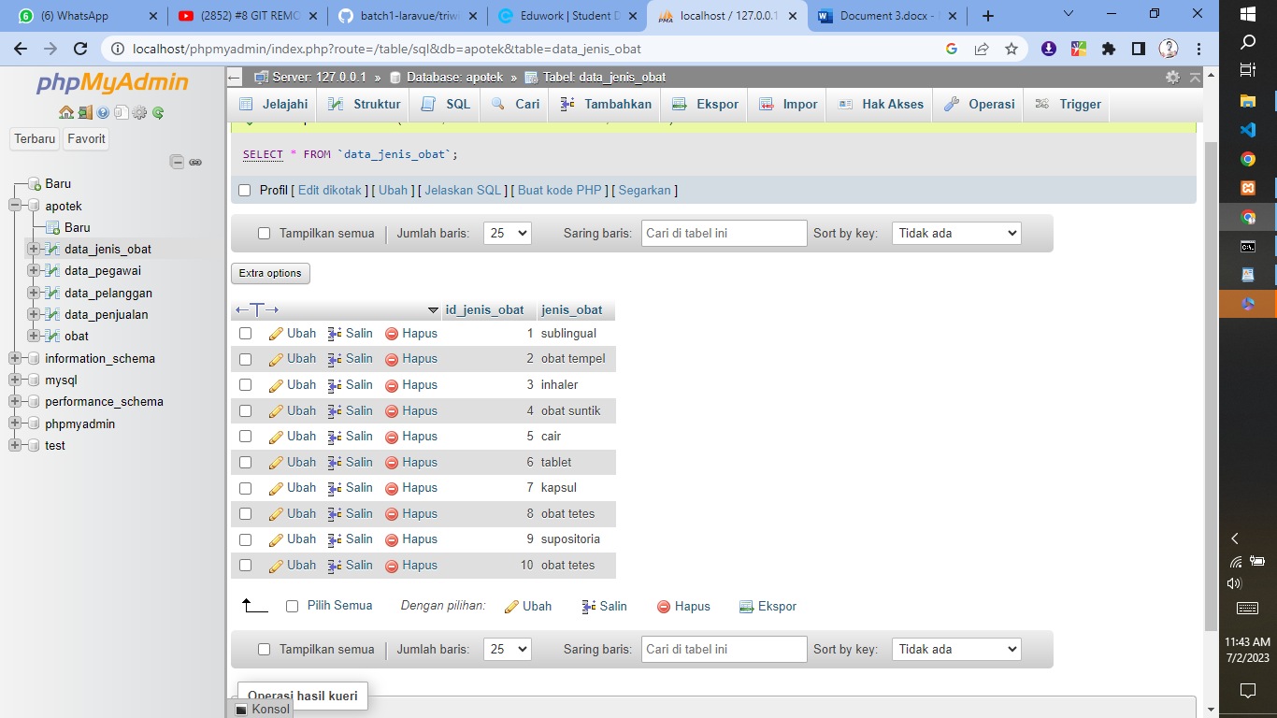

1. SELECT*FROM obat WHERE Harga > 3000

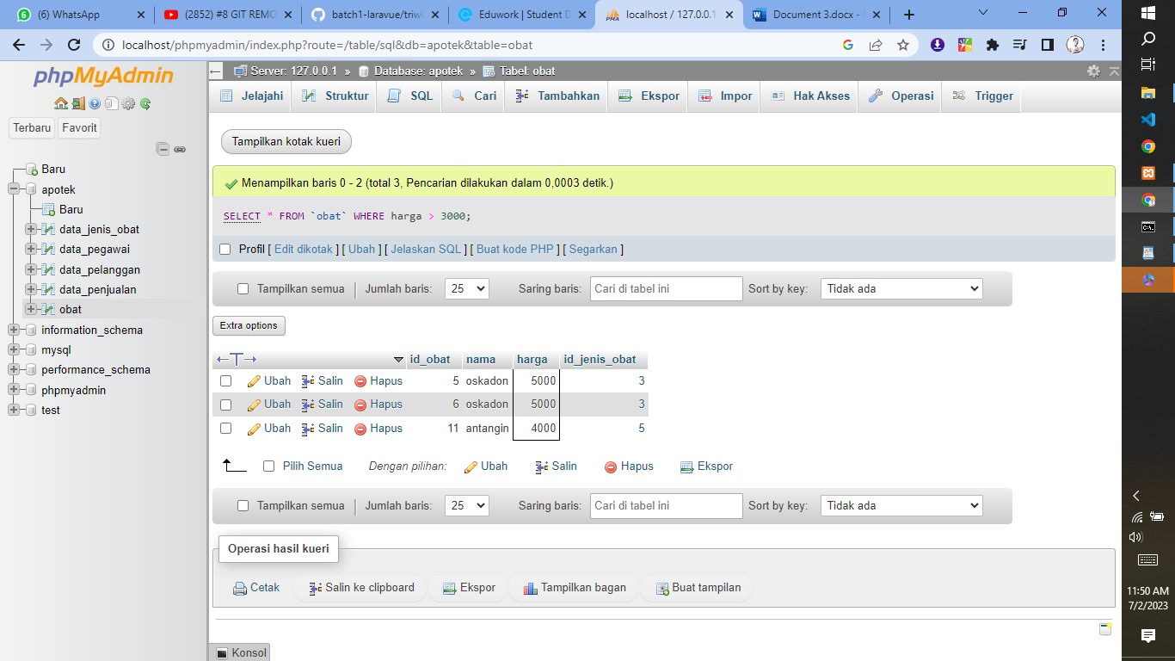

1. SELECT*FROM nama WHERE 1

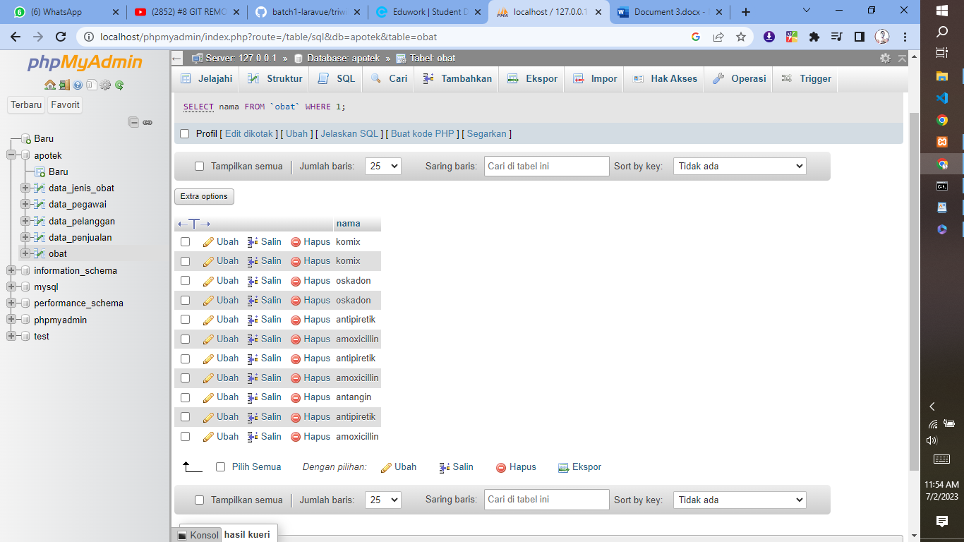

1. SELECT*FROM data pegawai

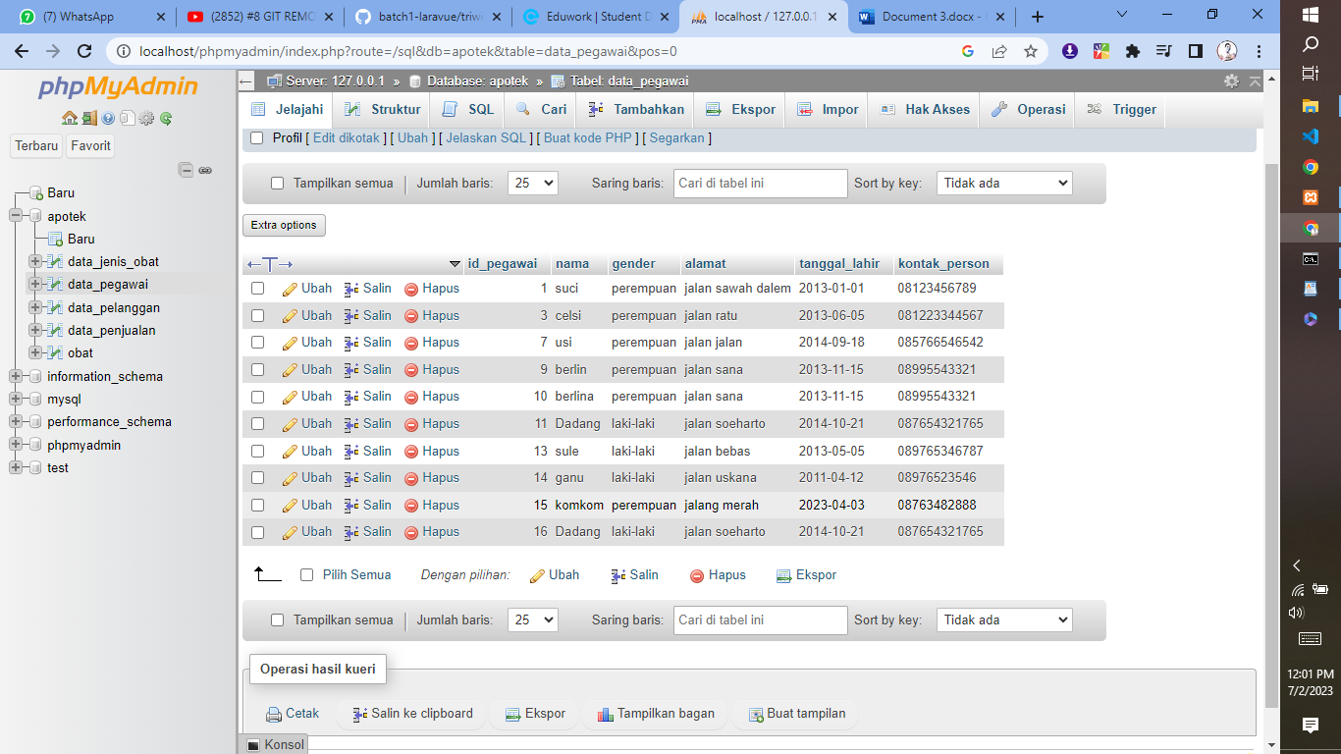

1. [SELECT](http://localhost/phpmyadmin/url.php?url=https://dev.mysql.com/doc/refman/8.0/en/select.html) nama, gender FROM `data_pegawai` WHERE tanggal_lahir > 2013;

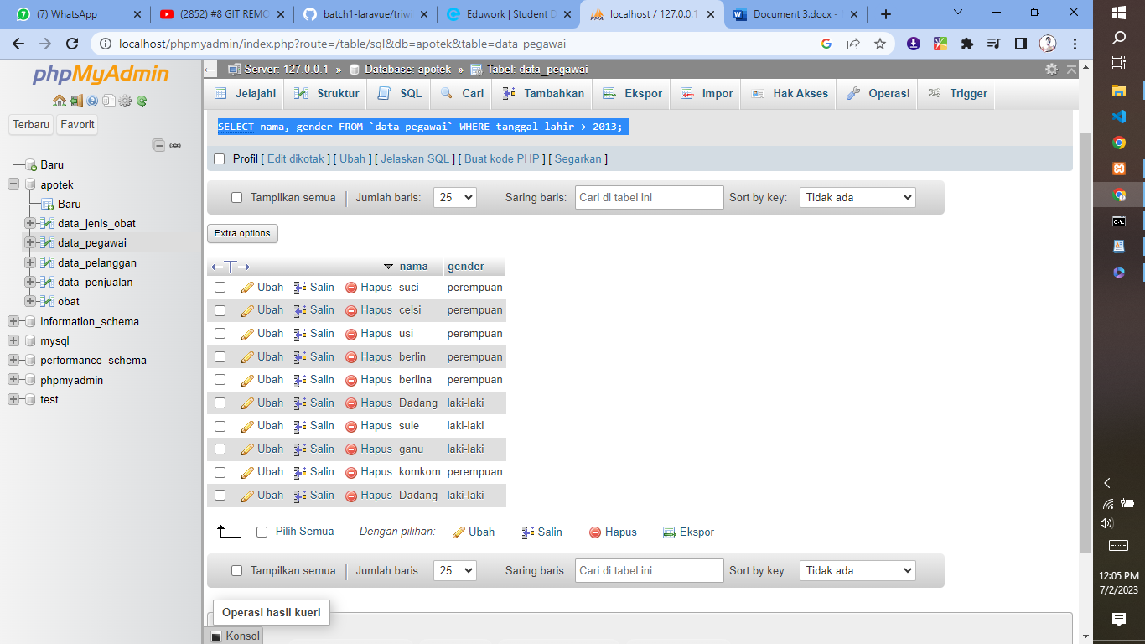

1. [SELECT](http://localhost/phpmyadmin/url.php?url=https://dev.mysql.com/doc/refman/8.0/en/select.html) id_pelanggan, id_pegawai FROM `data_penjualan`

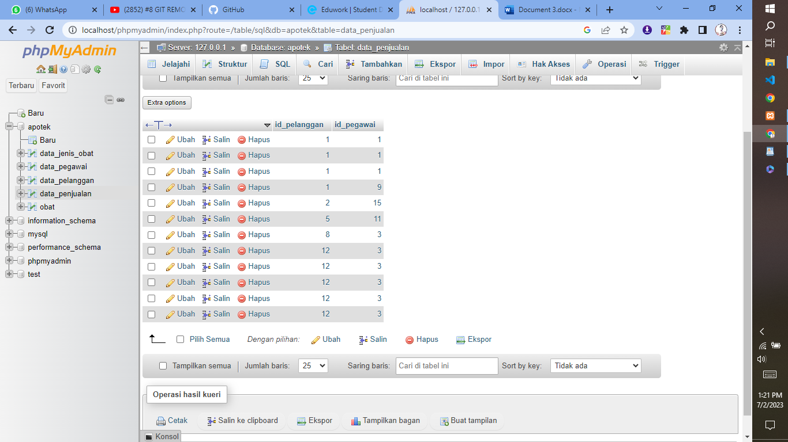

1. [SELECT](http://localhost/phpmyadmin/url.php?url=https://dev.mysql.com/doc/refman/8.0/en/select.html) id_obat, jumlah_obat FROM `data_penjualan`

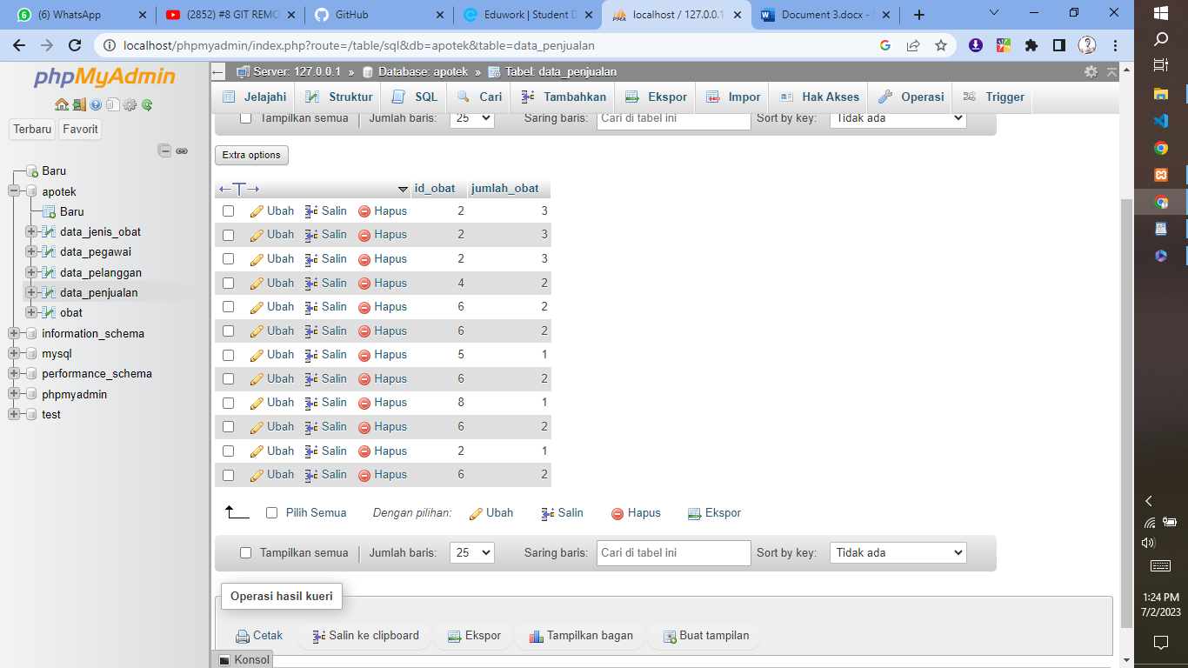

1. [SELECT](http://localhost/phpmyadmin/url.php?url=https://dev.mysql.com/doc/refman/8.0/en/select.html) nama FROM `data_pegawai`

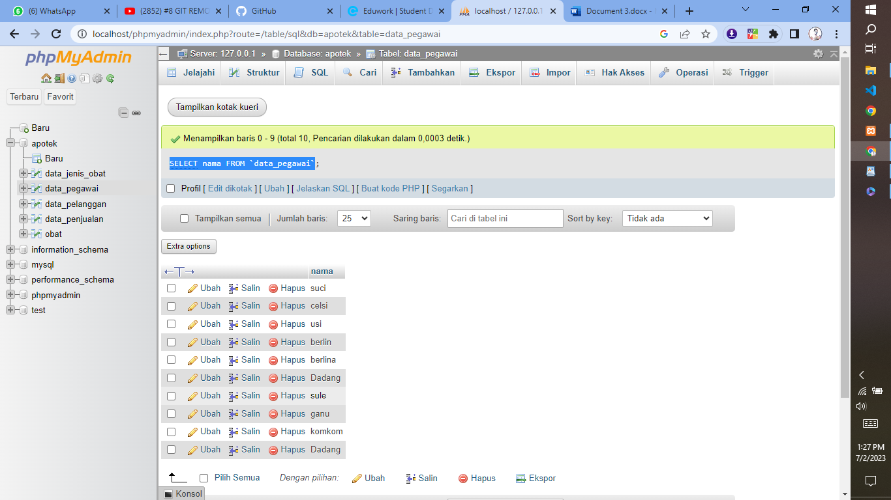

1. [SELECT](http://localhost/phpmyadmin/url.php?url=https://dev.mysql.com/doc/refman/8.0/en/select.html) nama FROM `data_pegawai` WHERE id_pegawai = 10;

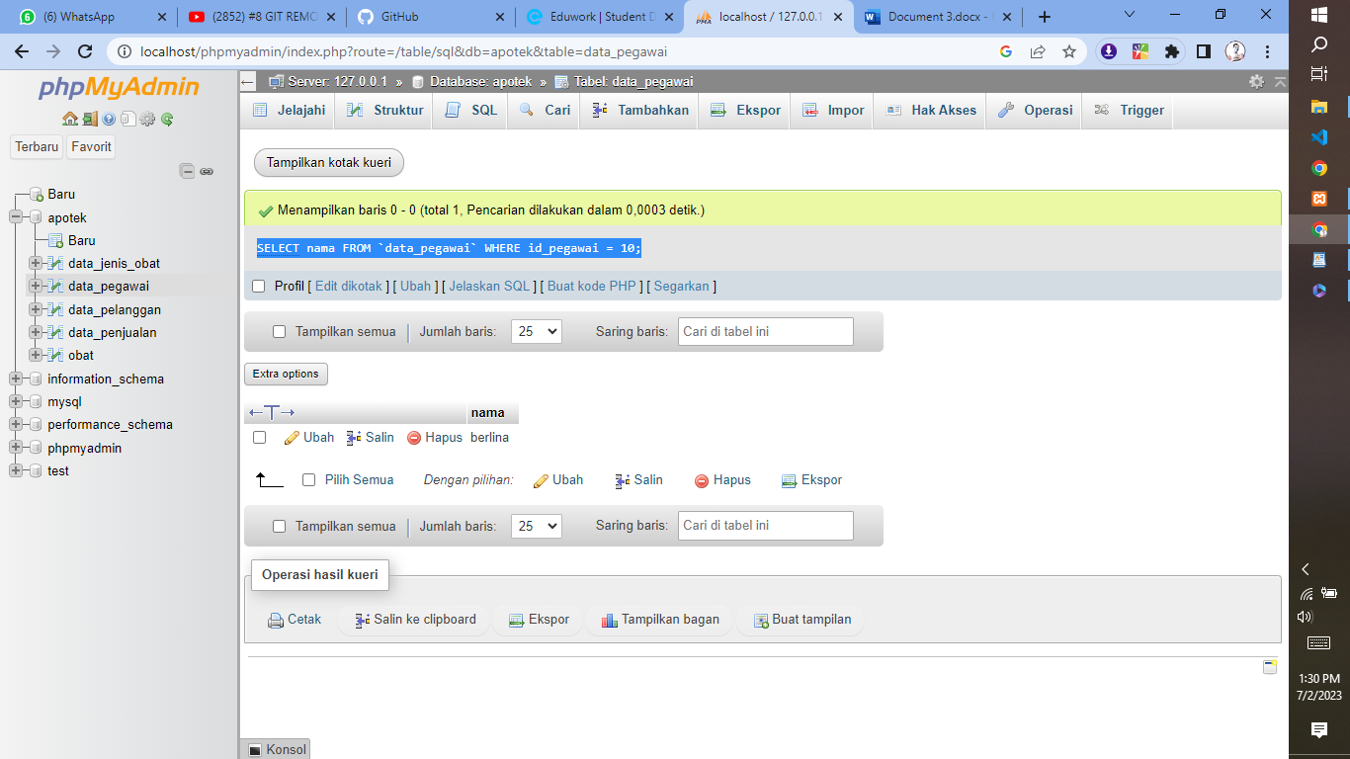

1. [SELECT](http://localhost/phpmyadmin/url.php?url=https://dev.mysql.com/doc/refman/8.0/en/select.html) nama FROM `obat` WHERE harga = 3000;

